Sales Forecasting Using Time Series Analysis

Forecasting Model Selection
To forecast future sales, the Holt-Winters Exponential Smoothing model was selected. This model was chosen because the monthly sales data exhibited both trend and seasonal fluctuations. Holt-Winters is well-suited for business forecasting as it can capture underlying sales trends while also accounting for recurring seasonal patterns. Additionally, the dataset consisted of only 48 monthly observations, making Holt-Winters an appropriate and interpretable forecasting technique.

Train-Test Split
The monthly sales dataset was divided into training and testing sets to evaluate forecasting performance.

Training Data: First 36 months (2014–2016)
Testing Data: Last 12 months (2017)

The model was trained using the first three years of historical sales data and then used to predict sales for the final twelve months. This approach allowed the model's forecasting ability to be evaluated using unseen data.

Actual vs Predicted Sales Analysis
After training the model, predictions were generated for the test period and compared against actual sales values.

The Actual vs Predicted Sales plot shows that the model was able to capture the overall sales movement and general trend patterns. Predicted values followed the direction of actual sales reasonably well, indicating that the model successfully identified underlying sales behaviour.

However, some large sales spikes were under-predicted, which is expected in smoothing-based forecasting models. While the model captured overall trends and seasonality, it was less effective at forecasting sudden extreme increases in sales.
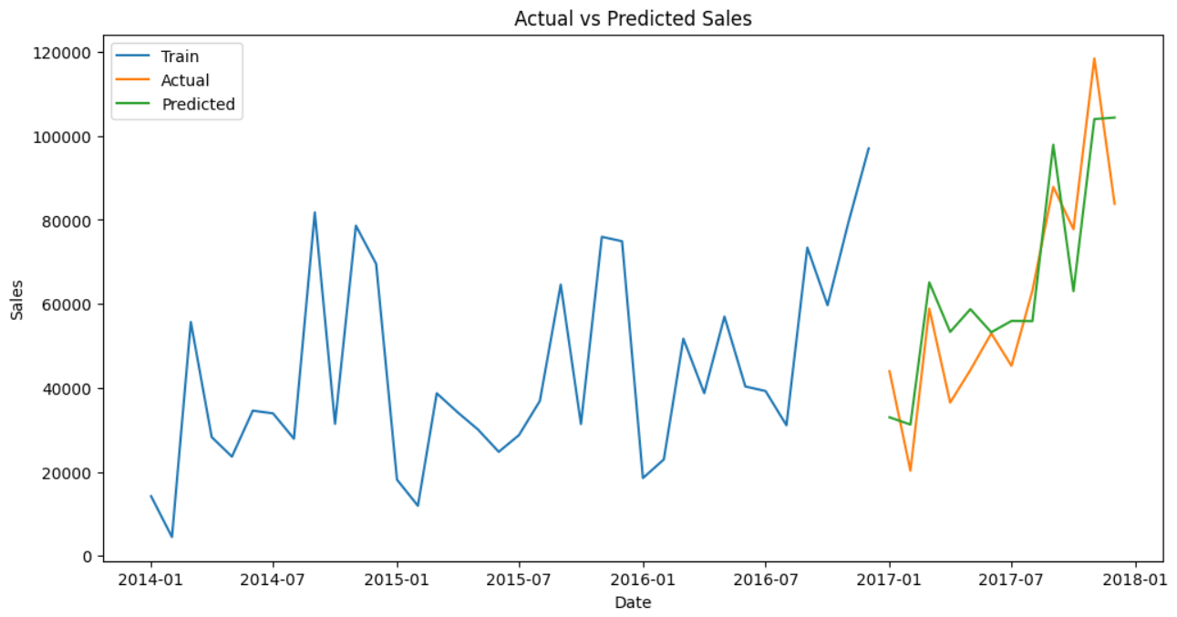

Model Evaluation Using RMSE
To evaluate forecasting accuracy, Root Mean Squared Error (RMSE) was calculated.

RMSE: 12,396.66
Average Test Sales: 61101.27
Forecast Error Percentage: Approximately 20.5%

RMSE measures the average difference between actual and predicted sales values, with larger errors receiving greater penalties. The model achieved an RMSE of 12,540.9, which represents approximately 20.5% of the average sales observed during the test period, indicating moderate forecasting accuracy.
Although the model does not perfectly predict extreme sales fluctuations, it successfully captures overall sales patterns, trend movements, and seasonal behaviour, making it useful for business planning and sales forecasting purposes.
Future Sales Forecast
Using the trained Holt-Winters model, sales were forecasted for the next six months.

The forecast suggests that future sales are expected to remain relatively stable, with moderate fluctuations throughout the forecast period. Forecasted sales range between approximately 42,000 and 75,000, indicating consistent customer demand and no major long-term decline in business performance.

The forecast shows:
- A short-term decline during the beginning of the forecast period.
- Recovery in subsequent months.
- Continued fluctuations similar to historical sales behaviour.
- No strong evidence of sustained growth or sustained decline.

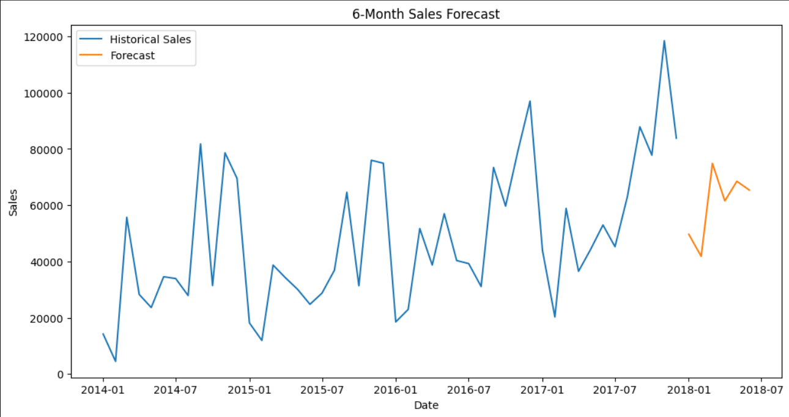

Business Implications and Recommendations
Based on the forecast results, the following recommendations can be made:

Inventory Planning
- Maintain inventory levels based on average historical demand.
- Prepare for moderate increases in sales during higher forecasted periods.
- Monitor inventory closely to avoid stock shortages during demand spikes.

Marketing and Customer Retention
- Focus on retaining existing customers to maintain stable revenue.
- Continue personalized marketing campaigns for high-value customer segments.
- Re-engage at-risk and dormant customers through targeted promotions and offers.

Revenue Growth Strategy
Since the forecast does not indicate strong organic growth, additional growth initiatives may be required.
Consider promotional campaigns, cross-selling opportunities, and customer acquisition efforts to drive higher future sales.

Forecast Monitoring
- Compare actual sales against forecasted values regularly.
- Update the forecasting model as new sales data becomes available.
- Explore advanced forecasting models such as SARIMA or Prophet in future analyses to improve forecasting accuracy.

Conclusion
The Holt-Winters Exponential Smoothing model was successfully applied to forecast future sales using historical monthly sales data. The model demonstrated moderate forecasting accuracy, capturing overall trends and seasonal fluctuations while struggling with extreme sales spikes. The six-month forecast suggests stable future sales performance with periodic fluctuations rather than significant growth or decline. These forecasts can support inventory planning, budgeting, marketing decisions, and strategic business planning while providing a foundation for future forecasting improvements.

